# Take home - Creating Cards (HTML + CSS + Bootstrap)

In this assignment you need to code out your own card from the given design.

## 

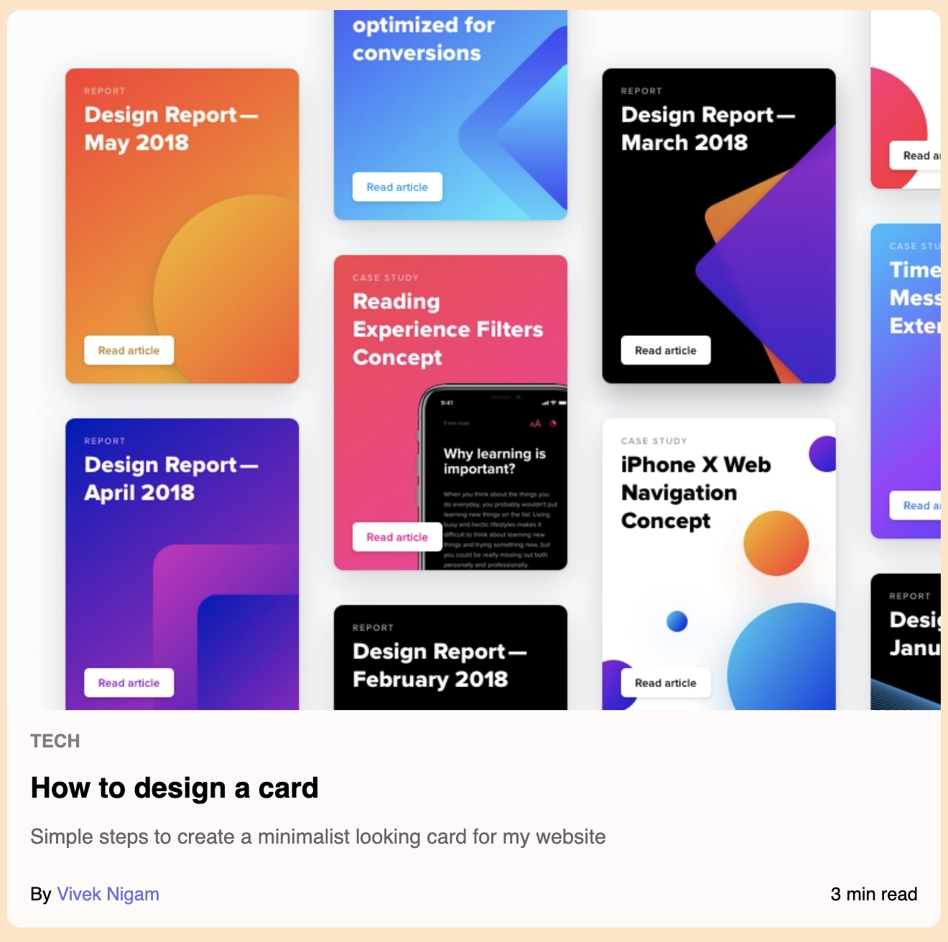

## Guidelines

* Try to break down this card into multiple smaller components given in this low-fidelity design below. Some hints are given below.

### 

* Remember to convert px absolute unit to relative (rem).

### Page Body

* Body Background color is #FFE4C4 **or** rgb(255, 228, 196)
* Font used is sans-serif

### Blog Card

* Should have a minimum width of 128px
* Maximum width of 256px
* Minimum height of 128px
* Border radius 10px on each side of the card
* Bottom margin of 16px
* Background color is rgb(255, 250, 250)

### Card Image

* The height and width of the image should be 100%
* The image should keep its aspect ratio and fill in the given dimension.
* The top left and right radius should be 10px.

### Card Content

* Padding on left, right and bottom should be 16px.
* Padding on top should be 0px.

### Card Body

* Overline is h2 of size 12px, always uppercase and opacity 50%
* Heading is h1 with size 21px. Bottom margin is 24px
* Paragraph text is of opacity 60% and font size is 14.4px

### Author Link

* Should have no underline on it, but should be a link.
* The default and visited link color should be rgb(109, 109, 235)

### Card Footer

* Should have font-size of 12.8px.
* Align-items to the center and justify-content as space between.

## Appendix

### Card Image Source

"<https://cdn.dribbble.com/users/606683/screenshots/4704119/article-cards.png>"

### Starter Code

<!DOCTYPE html>

<html>

<head>

<link rel="stylesheet" href="styles.css" />

<!-- Add any other stylesheets here -->

</head>

<body>

<div class="blog-card">

<div class="card-img">

<!-- Add Card Image Element here -->

</div>

<div class="card-content">

<div class="card-body">

<!-- Add Card Body Elements Here -->

</div>

<div class="card-footer">

<!-- Add Card Footer Elements Here -->

</div>

</div>

</div>

</body>

</html>